Real Estate Amber

Socio-Technical Perspective

Demo

Contents

About Real Estate Amber 3

Introduction 3

Rich Picture 3

CATWOE 4

System Levels 4

Root Definitions 5

Conclusion 6

Glossary 6

Table 1 - 5Es Transformation 5

Figure 1 - Rich Picture 3

# About Real Estate Amber

Real Estate Amber (REA) is a new web platform designed to allow a fast and reliable means to search for, and sell, private properties, regardless of their size and price. Its modern design, along with the innovative technologies used, make Real Estate Amber website a sound choice for buying and selling your properties. And it is very easy to use ! All you need to do is to make an account, which shouldn’t take more than a minute to complete. Then you simply have to post your property, along with a few details, and you are done !

Amber, dedicated to finding you your dream home !

# Introduction

This document will present the socio-technical aspects of REA, using a soft system approach. A general view of the project will be presented, from which further analysis will be generated. The focus here is the human element in the system, and will be presented from the actor’s / stakeholder’s point of view. In addition, the document will cover the problems solved by the software product itself. The technique used to analyze the scenario from a socio-technical perspective is the Soft System methodology (SSM).

# Rich Picture

One of the first elements needed to understand the system is a rich picture, i.e. an illustration of the environment with the system, devices, and actors included. It presents, in a simplified manner, what each user is performing. 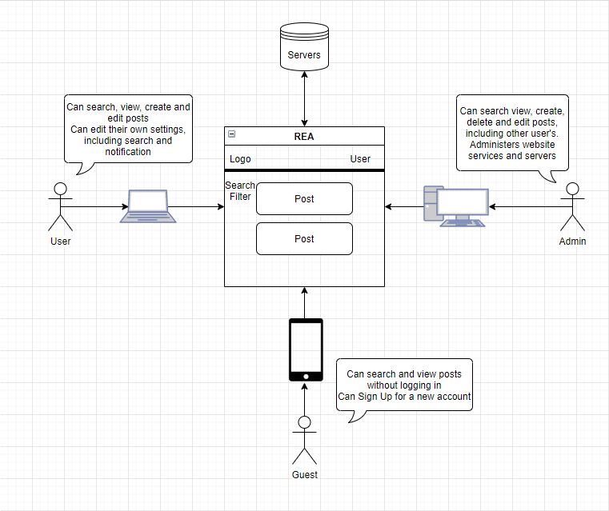

Figure 1 - Rich Picture

According to the figure, REA helps users and guests alike to better purchase or sell private properties, in an efficient and fast manner.

# CATWOE

Once the general view of the REA system is established, all elements must be properly identified and represented. Given the socio-technical focus of the document, the worldview perspectives of all humans interacting with it must also be included, to better understand the roles and impact each one of them has. This is achieved through the CATWOE table – Customer Actor Transformation Worldview Owner Environment

|  |  |
| --- | --- |
| **Customer** | **Worldview** |
| Users | Means to both purchase and sell private property |
| **Actors** |  |
| Admin | Perform maintenance and updates, provide support, add features, manage user activities and accounts |
| Guests | Means to search for posted properties |
| **Transformation** |  |
| Settings |  |
| Home Page |  |
| **Owner** |  |
| CEO | Offer a means for people to achieve goals and find the best deal for their homes |
| **Environment** |  |
| Real Estate Amber |  |
| IT |  |

Table - CATWOE

As shown in the table, there is one customer aimed at, the User. There are 2 types of users : the general User, making up the bulk of users, and intended target, and the Admin, privileged special users.

The Guests are a type of Actor which are not Users, since they do not poses an account, or have not logged in with one. They can view and search for existing posts.

Admin are a special type of Users, which have special privileges to provide support, maintenance, and update services, while also monitoring user activities and accounts when needed.

# System Levels

The overall system based on which the view is created is REA. It is in this context that the system is shaped, modeled, designed, created and validated. The product created comes in the form of a website and mobile application, to act as a means for people to get in touch with others, in order to facilitate a fast and efficient transaction.

REA is comprised of a number of subsystems, which end up defining the project as a whole. Due to the diversity of functions and roles, it is comprised of :

* Create account & Registration
* Login & Authentication
* Sessions
* API routing
* Create & manage Property Posts
* Manage account
* Notification
* Messaging
* Search

|  |  |  |
| --- | --- | --- |
|  | **Transformation** | **Explanation** |
| **Efficacy** | The means work | The actors achieve their goals |
| **Efficiency** | Minimum resources required | The minimum amount of time to find a good deal or to sell |
| **Effectiveness** | Helps the attainment of the Owner’s long-term plans | Users have a better way of showcasing what they are selling. Guests can be persuaded to make account |
| **Ethicality** | Is morally right | Helps people better sell their property, without moral issues |
| **Elegance** | Is aesthetically pleasing | Nice, modern webpage, with a stylish design |

Table - 5Es Transformation

# Root Definitions

Root definitions help understand a definition of the nature of a purposeful selling system like ours. In other words, it’s a PQR-form description (PQR by themselves stand for nothing, but they do have a meaning : **P – What, Q – How, R – Why**). The formula is a sentence in the form of :

Do **P** by a **Q** in order to achieve **R**.

The definition covers the most important aspects of REA, explaining what it achieves, the means to do so, and the motive behind it.

For the REA System, the list of rot definitions would be :

Allow communication between users (P) by allowing all users to be in contact with each other through the use of comments (Q), in order for them to get in touch with each other and exchange a transaction, details, and feedback (R).

Allow file management (P) through the upload of images (Q), in order for the users to more easily exchange the nature of their property (R).

Allow users to keep track of any new content of other users (P), through the use of a notification system (Q), in order for them to be up-to-date with the latest changes and news regarding favorable posts (R).

# Conclusion

From the project’s perspective, it helped to :

* Get a wider understanding of the problem (Rich Picture)
* View it from several different perspectives (CATWOE)
* Identify the changes in the system (Transformations)
* Confirm the benefits (5Es)

From the SSM technique overall, we can see how these models have helped in various ways to get a better understanding of the problem faced and view it from multiple points of view.

No further issues have been identified at the moment.

# Glossary

SSM – Soft System Methodology

CATWOE – Customer Actor Transformation Worldview Owner Environment